Splunk 6th and 7th day session: Admin second part!!

In Search, u can change the time zone, and check it But if while coming it wil take its std format. So timezone settings helps to view the data in desired format but which will not change the incming file.

For eg, if we will not specify the time then it will take default format

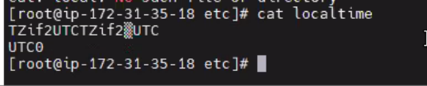

If your time stamp in one format, that format will be considered as index timestamp. For eg. If u r indexing one day prior time, then it will take that as it is

**Splunk Managing Apps:**

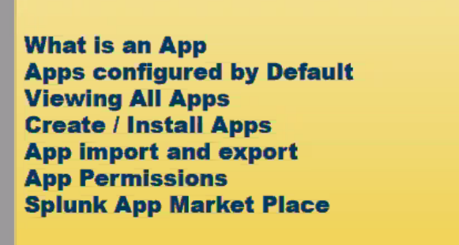

Heavy forwarder: it will receive data from dif universal forwarder and majorly it does filtration but not indexing and then forwards data to indexer.

If lines are not really required, then we can ignore/skip those using heavy forwarder.

We will not do for indexing but just we configure to senddata to receiver

If you go to splunk base.com wehre u can get apps wrt to dif integrations

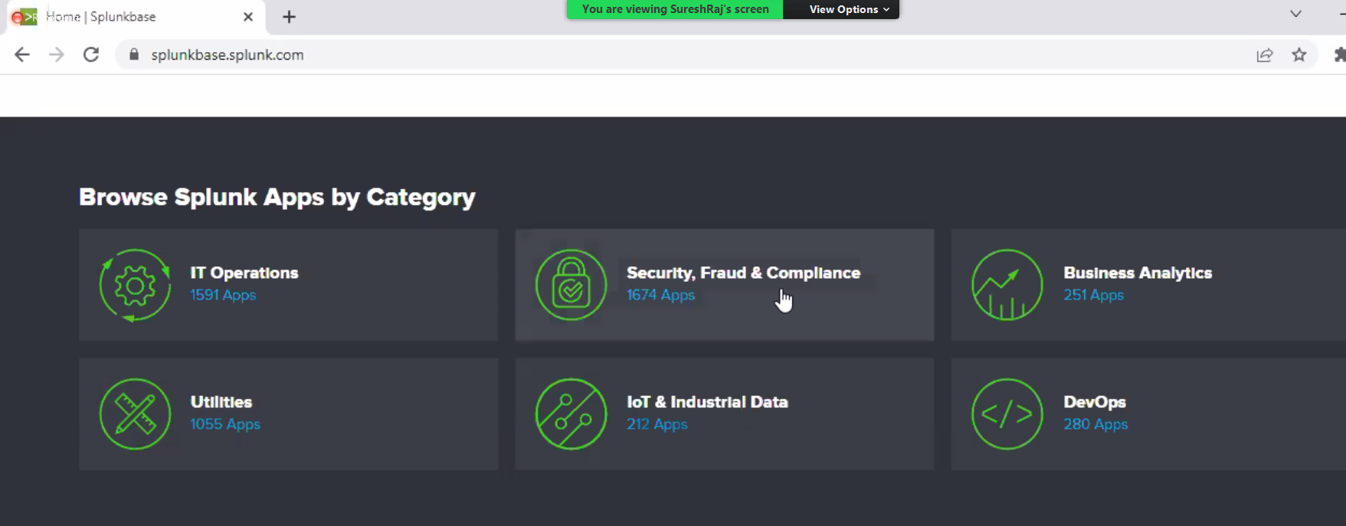

If security team or other team wants to have secured way of apps then u can create it using manage apps or else u can use/install under splunk base.com

/splunk/splunk/etc/apps ->where we can see apps with its folder structure

If we create apps that also comes with update checking- yes

Browse more apps option  
install app from file

To know more about license , u can also install license usage from base.com

Install app from file:  
if we have restriction to prod due to vulnerable, we go for this to install app  
we can also use website moniotoring-> to moniotor web logs. N u can download n install if u dnt have permission to browse

**If we dnt have internet, but still if we want to montor weblogs in splunk then u can use proxy one bcz most of splunk doestn have net access**

**If we have net like we have now, u can simpluy click save cconfiguration.**

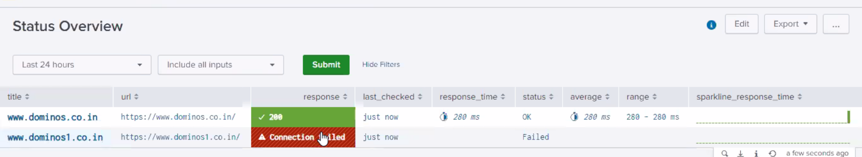

**Here if u see if we give wrong url under create input, it will give immediate one.**

**Intra net(splunk n/w reachable within org site) then we can use it as it is**

**Note: *If we install*** *any customized apps, it will point to some index and displays tathe data, And now we have to modify wrt to our requirement by pulling data to specific index that is one option.*

*But* ***we have some apps which will not allow option to edit the xml. Here we have one chcallenge.***

***And if the app works, then we shd have data in splunk.***

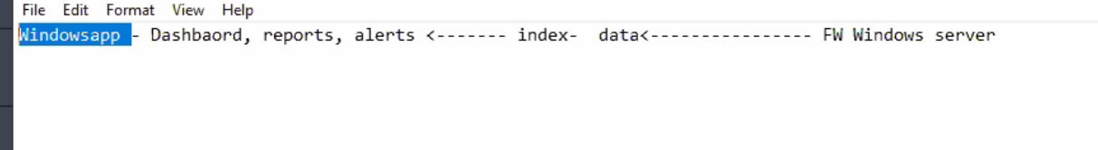

***If we have requirement to push eventlog, system logs, security log , application log etc.. until unless we will not collect data wnt get displayed.***

***So, there shd be someone shd help to store data and to push data as well. That’s where Splunk add-on comes into picture. It helps in 2 ways as mentioned below***

***Whenever app gets published to market, splunk add-on is kind of app which helps to cteate index and also helps to collect data from forwarders.***

***As soon as u create add-on app, by default it will create index automatically. Similary it will create add-on and we can keep under /splunk/splunkforwarder/etc/apps***

***Note: if*** *we need to push data from Snow on our system then add-on shd be fine. But if we want to collect data from multiple system then we shd install both add-on, as well as apps.*

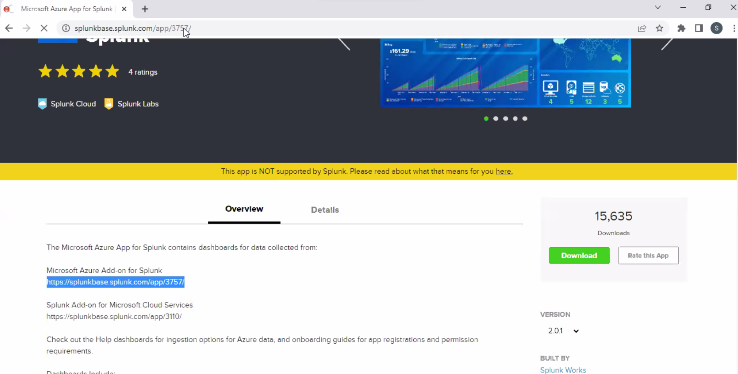

*Here if u see wrt to this app we shd install mentioned add-ons*

*To create add-on for ur own app, then under manager apps, create app and gicve name as addon and give visible as* ***NO***

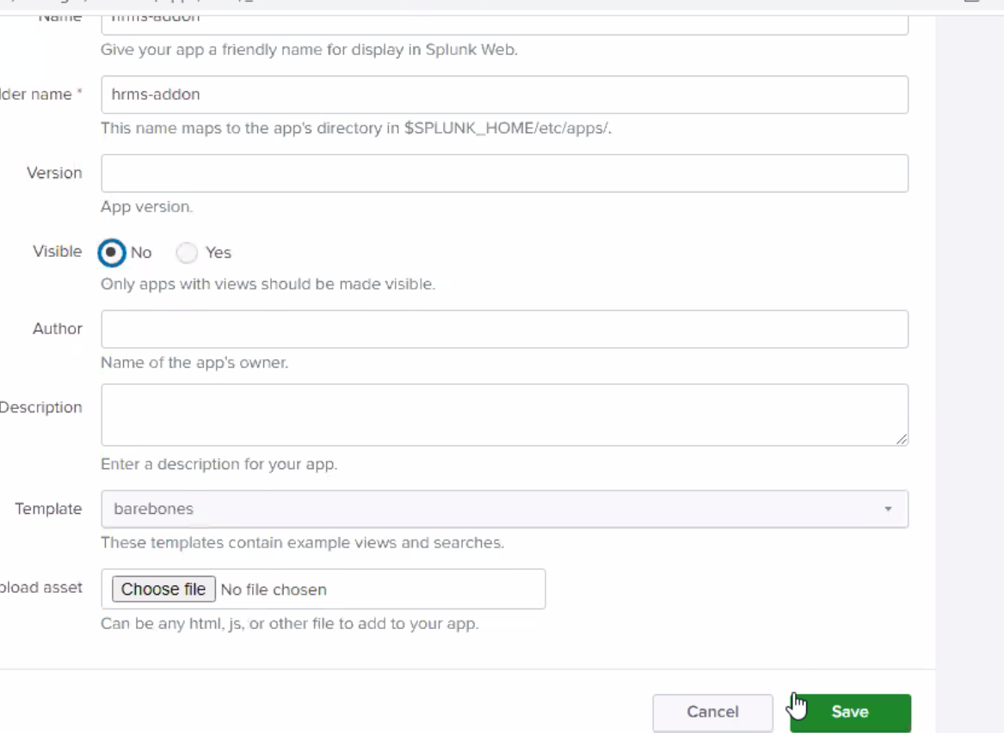

*Under Bin, folder we can keep scripts which we can define under inputs.conf as similar to checkpoint.*

*Index Management:*

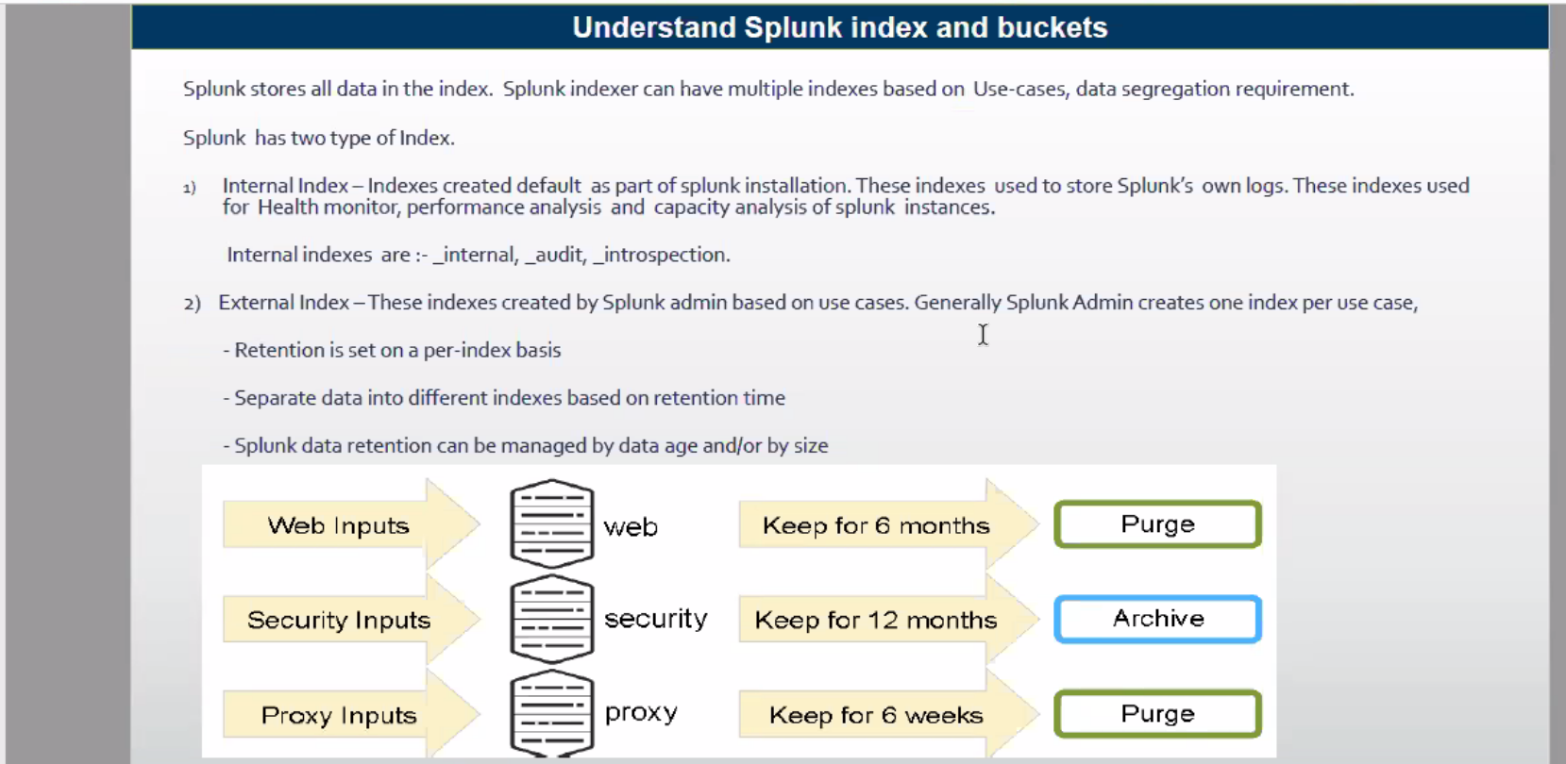

***Always we shd keep data in separate index to monitor and if we have common index and if we keep bot data since retention period is dif, its difficult to maintain and also there wud be risky with retention***

*When data comes from source, it wil come as raw data and store as* ***raw data. For eg,*** *if we push apache logs and then it will store as raw data. And* ***it will use internal algorithm to make data to read much much better.***

***Internal index->created by part of splunk installation***

***/var/log/splunk->all logs from this splunk interal pushed to _internal  
why we use _internal->splunk has error, cpur utiliztaon, everything all captured under this log.***

***Note: If any error, then u can jus restart server***

***How come data stored in splunk?  
it will get stored in _internal,_audit,_introspection***

***Version of nodes, inventory version, cpu utilization etc..***

***If we have external index and then how it works?***

***Whatever we are createing that wil comes under external index,***

*License calculation will be calculated only for external index,*

***If data size is huge in size of tB or GB, if we go for such huge data, then if we have good performance we will get data asap,***

***But if we have issues with license size, then it will not lead to performance issue because it will just stop search but index continues.***

***Prforance issue usecases:***

* ***Amount of data (if its huge)***
* ***Hardware***
* ***CPU***
* ***Memory***
* ***Disk***

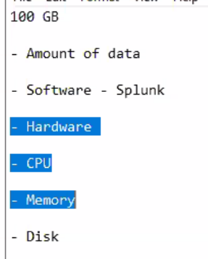

***Here 60% decide on first 5 but last disk alone decides 40% of it***

***If we go with SSD it will be faster compared to HDD now mostly they use SSD. So SSD will give better performance***

***If ew have 100GB, 100*30*6  
300*6 ->1.8TB***

***100GB, 30 days, 6 months->to calculate  
here we are actually considering for multiple SSD’s***

***So before configuring, we shd discuss and fix this as main point.***

***Here if we have SSD, it will cost much so we shd think other way***

***But of we go for, HDD, peforance will not good.***

***Data nature  
30 days- frequently  
30 days for 6 months->its moderate  
after 6 months->we will not even monitor’***

***Here we data nature, so here we can go with index rotation concept.***

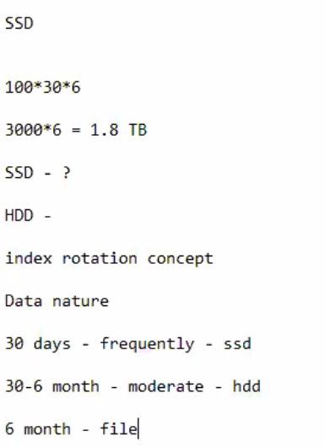

***Here if data comes older than 6 months it will psuh to HDD, and then to file. Here where bucket concept came into picture,***

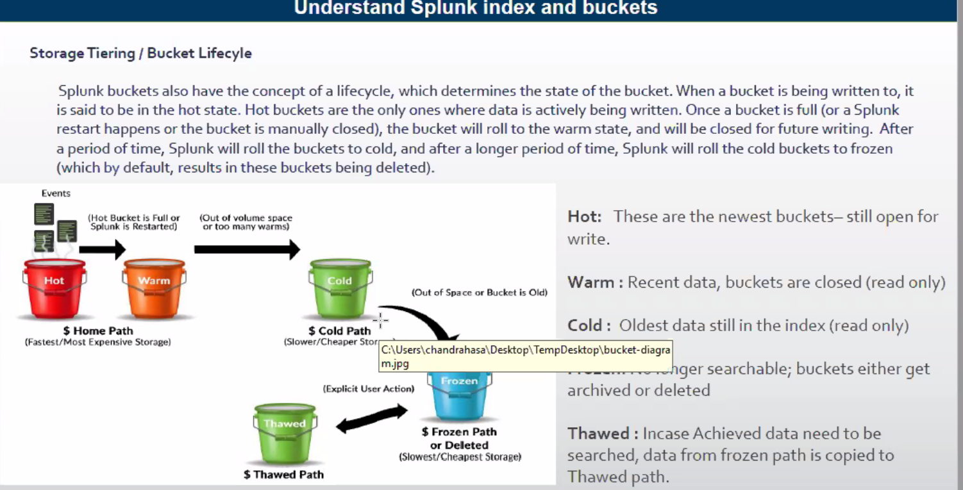

***Thawed path will not come by default but if we want we shd define it manually under conf file.***

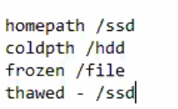

***If u r dnong in linux server, we shd request linux team to mount /ssd and /hdd as well as /file  
here we can ask them 1TB for /ssd. 5tb for /hdd and 10TB for /file***

***Here we will not do on our own and instead we request liunx team to do it.***

***Here in AWS. We will do under volumes and to check the same, we can do under lunx session***

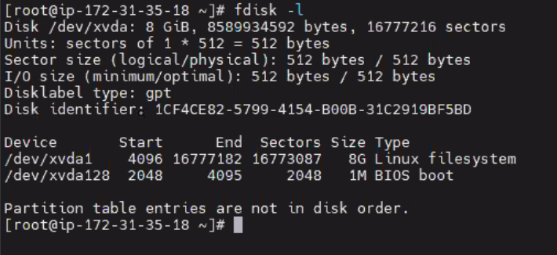

***Here if u see, we assigned 8GB so it comes like this. To check we shd use fdisk -l***

***If we need more then we can ask team to do it.***

***Similary we can request /ssd and /hdd as well as for /file and we can ask team to perform it***

***Go to settings->index  
What is the difference be/w metrics ane events***

***Events->more related to log files.  
metrics->numeric values such as CPU ,temp utilization, mainly we use for arithemetic calculation***

***Events are always irregular. Because it will not come always and it will come depends on generation***

***But metrics, we shd monitor every sec/min for the day and here we shd monitor and shd display the dta. So here we shd calculate aount of data*size*perday ->likewise we can calculate for month and shd increase index structure.***

*If u r sending data to metrics type and we can see better performance but still it has few impact on performance*

***Path of index:***

***We have logs stored in /var/log/splunk***

***But where these index stores in splunk***

***Its $SPLUNK_DB, similar to linux we also have SPLUNK_DB home and its path is </splunk/splunk/var/lib/splunk>***

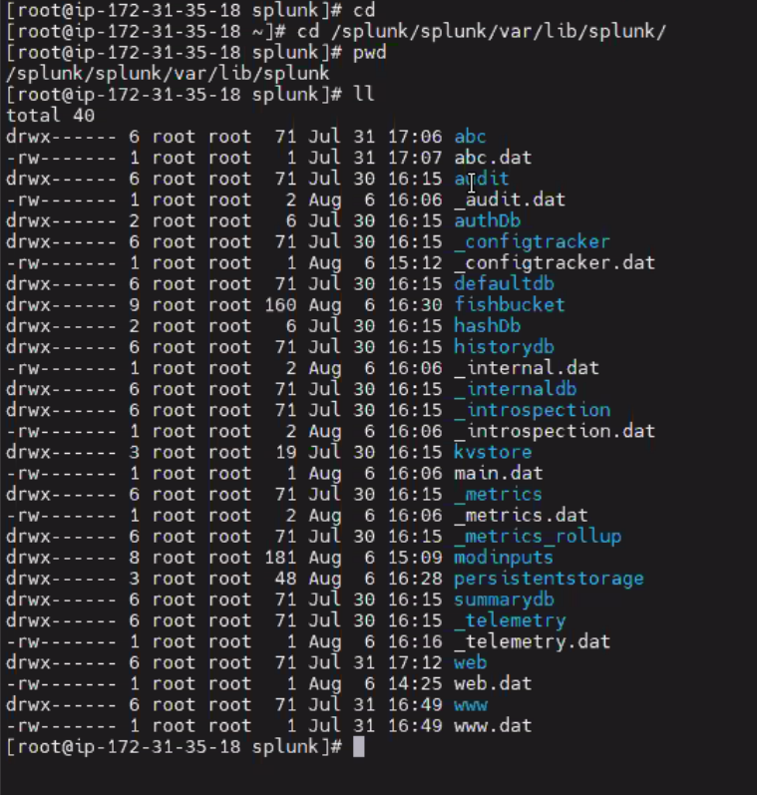

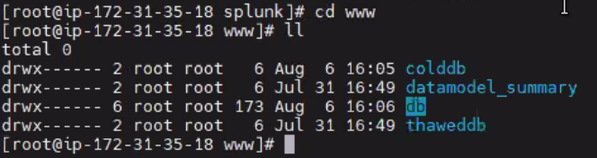

***Here if we see we dnt have frozen which means after sometime, data will get deleted,***

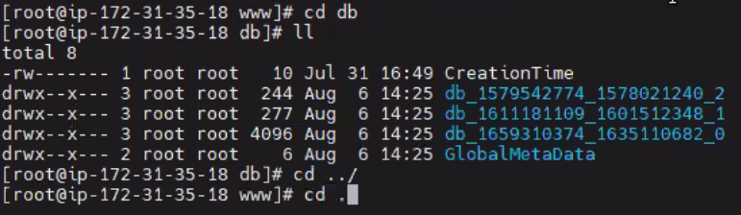

***Here if u check under /db, u can see only hot***

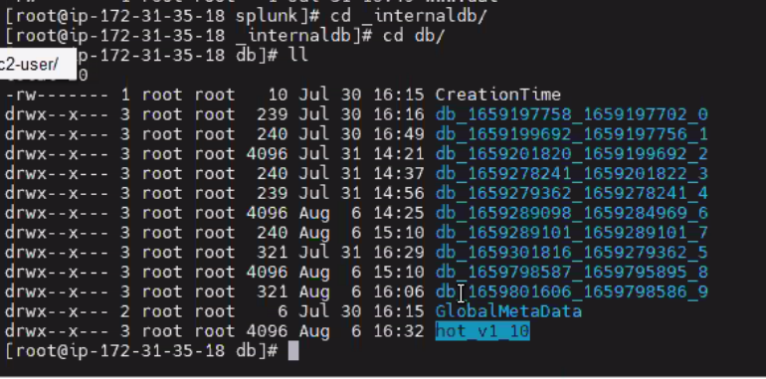

***Here if u see, we can see hot bucket.. under _intenralDB as well. Where we can see file.***

***In distributed env, we shd define replication factor to have how much copies of data.***

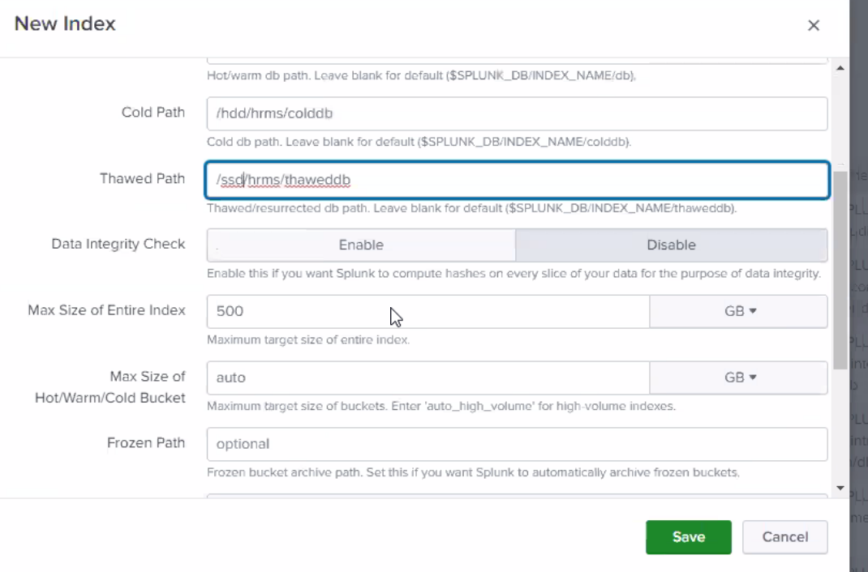

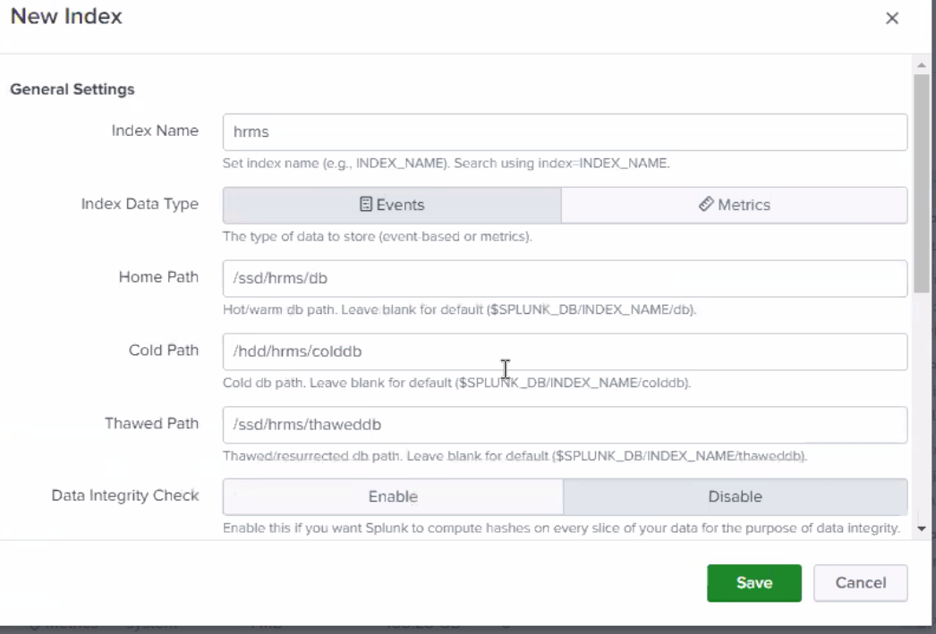

***For frozen it shd be /file/frozendb***

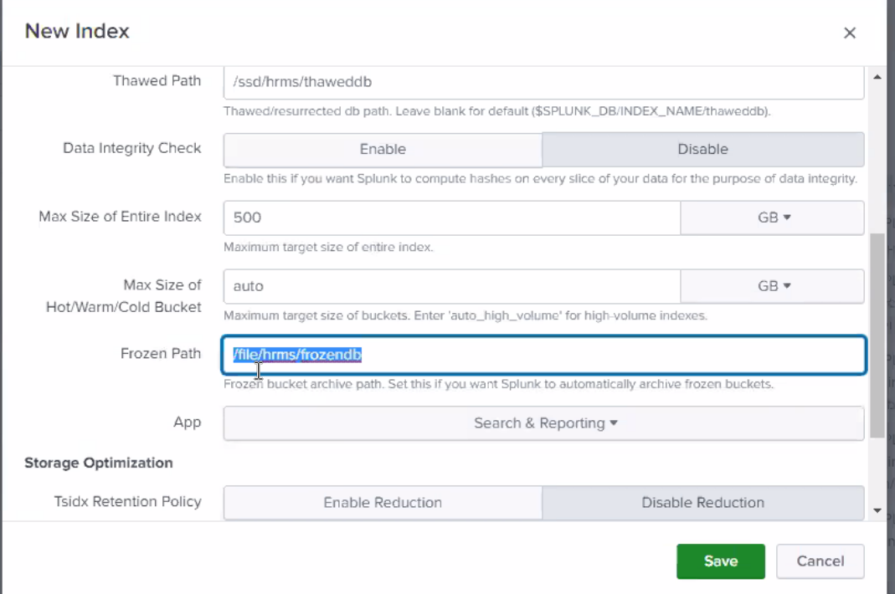

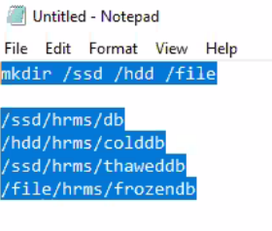

***Data integrity check:***

***Once u brought data to splunk and if u shd not modify then u shd use enable data integ check then splunk will create # algorithm for each index(index wise approach), and if any one modify, then we cn check in CLI. Mostly we will not use it.***

***And if u want to keep index in specific app, then u can use this***

***Max size index->calculated based on sum of hot+warm+cold***

***Now, we set index under specifc app. So to check index use below***

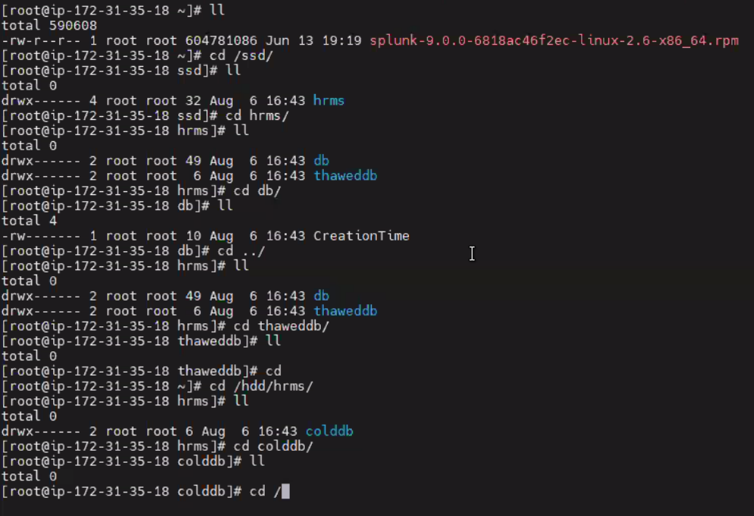***’here if u see, we can get those db’s under specific one.***

***Copy data here***

***Entire folder will get replicated while using replication factor.***

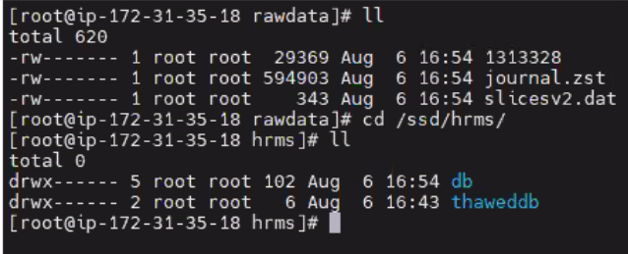

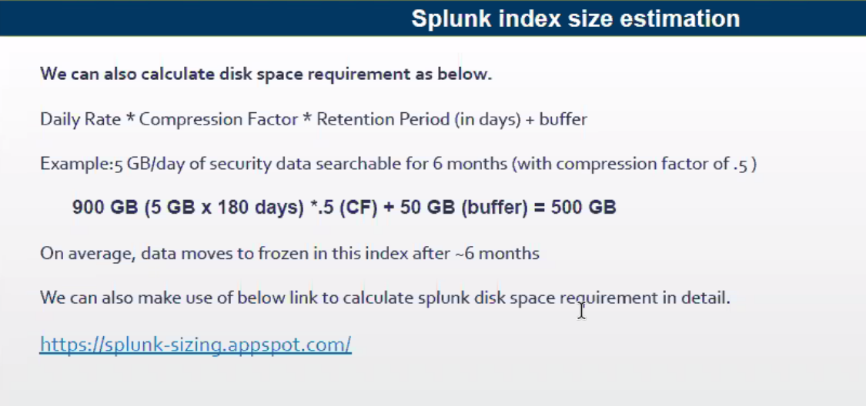

***Here to calculate data, we have link to check. And depends on that, we can calculate***

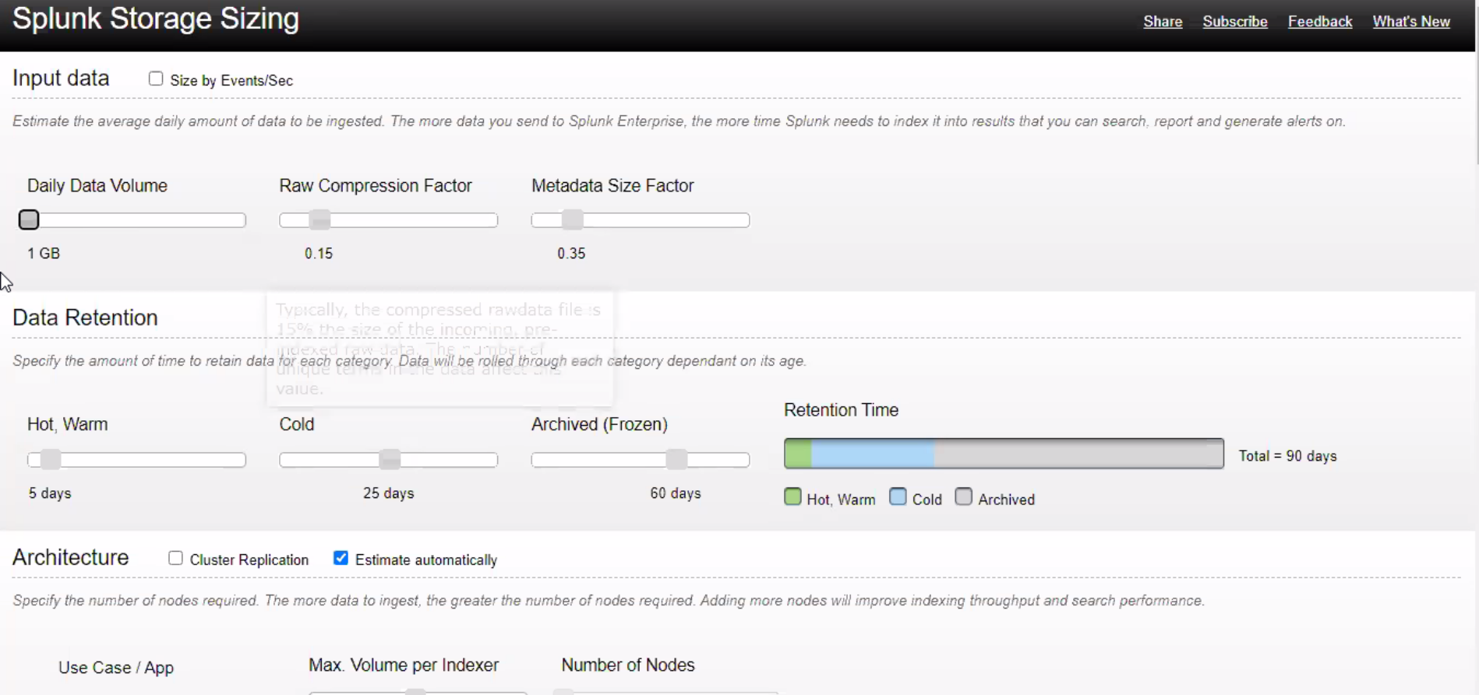

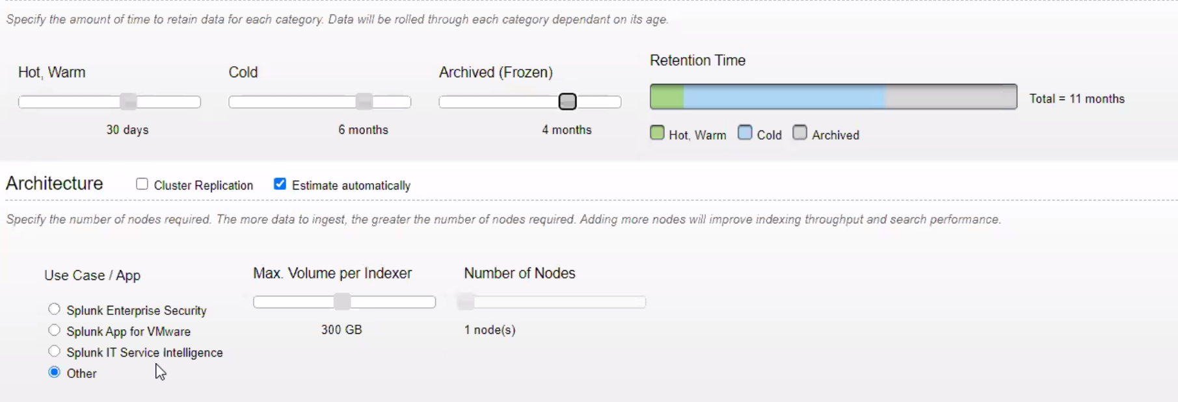

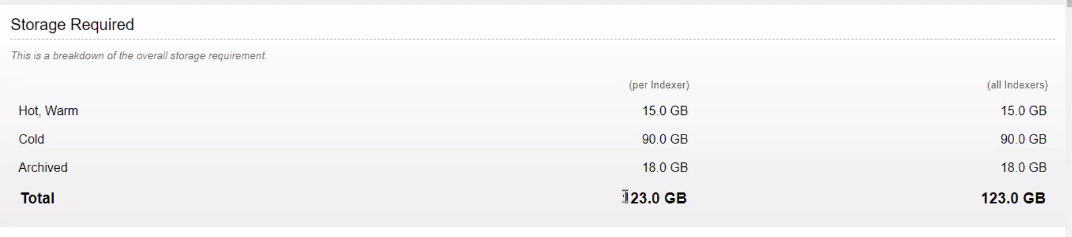

***Here we can get data.***

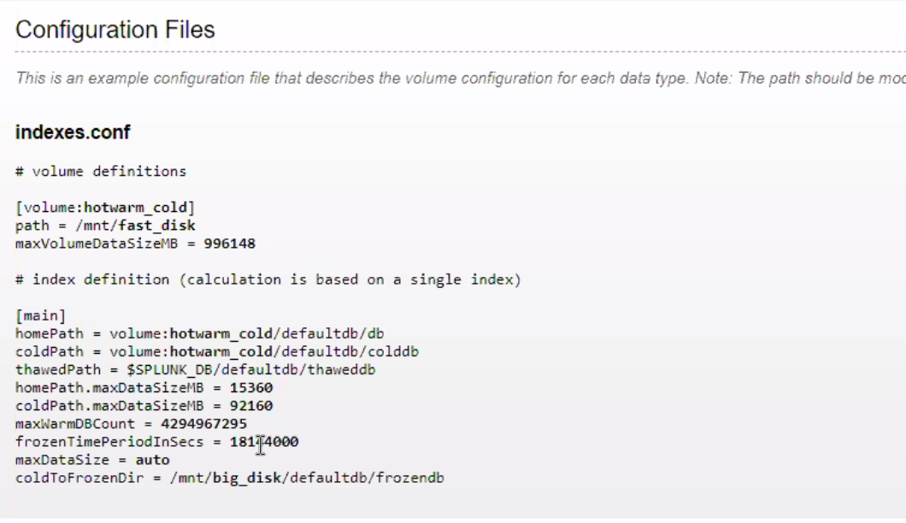

***Using this we can define and change name and apply***

***For cluster, u shd select cluster option***

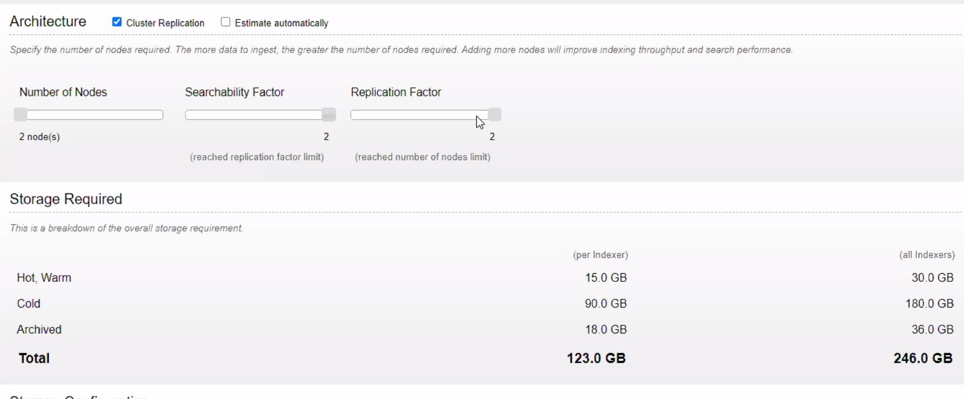

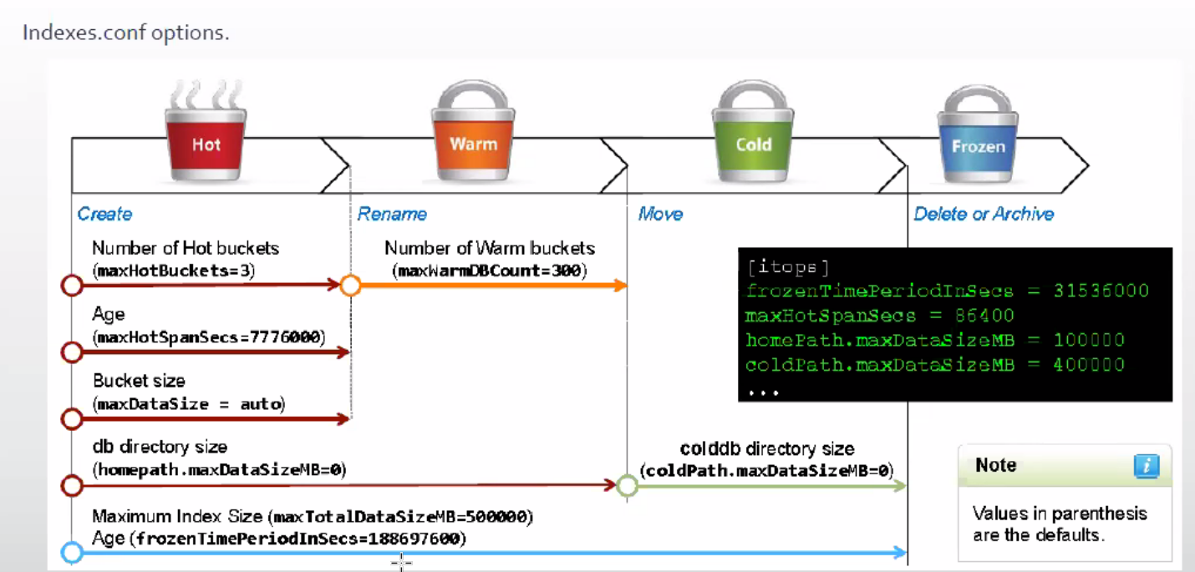

***Here we only defie last 2 part/***

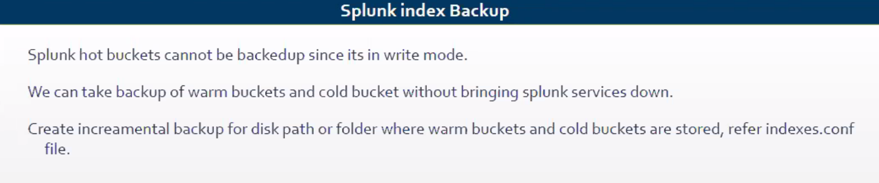

***We have lot of backup tools and if we request agent they will ask which folder to take backup. If we want to take specifically hrms then u can say /ssd/hrms/db  
/file/hrms/frozendb***

***Once we share, ew shd also specify interval and rentiaon policy as well.***

***We cannt do for hot db since its open mode.***

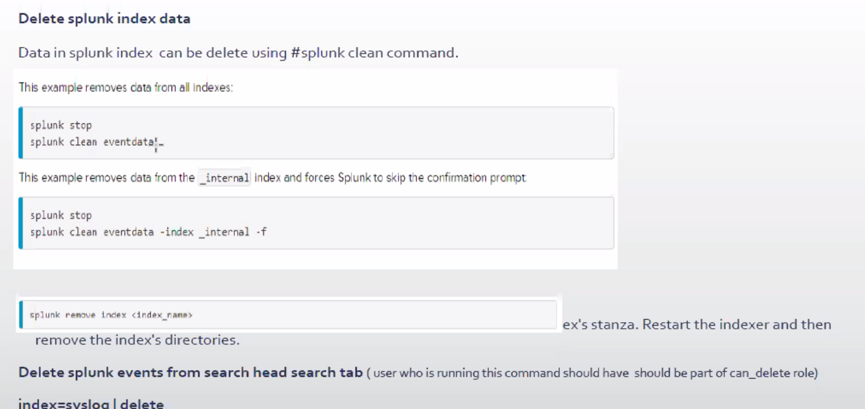

***To delete entire data form splunk u can use clean eventdata***

***Another way to delete index if we have critical sefrerf and if we want to delete the u can also use delete command***

***Here -f represents force***

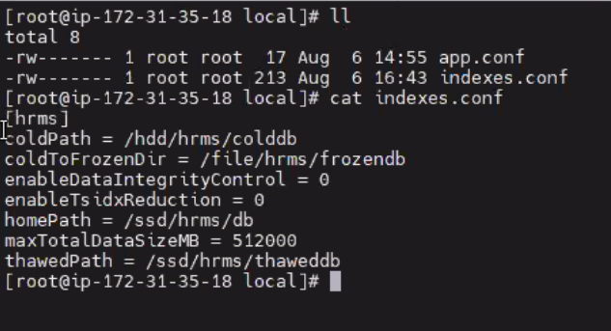

***Taking backup for entire folder for now using cp command. But in prod separate team will do***

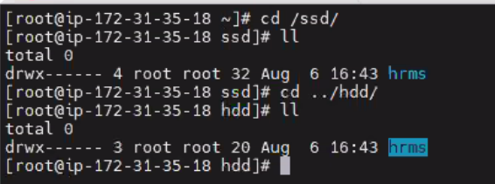

[Manage data integrity - Splunk Documentation](https://docs.splunk.com/Documentation/Splunk/9.0.0/Security/Dataintegritycontrol)

Data integrity check concepts

**7th Day session**

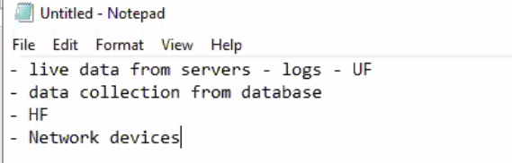

N/w device ->firewall, load balancer

Via UF, we shd install UF in source and config to forward data to indexer.

But if we have more UF, then we shd config at UF(what data needs to be send(inputs.conf) and where to send data(outputs.conf))  
  
if we have more UF, then we can install deployment server and create add-on and pushd respective data like windows to winodws specific add-on and then we can push those specific changes to UF

there is designated folder **structure for deployment server ->/splunk/splunk/etc/deployment-apps and here if we keep add-on and which helps to push data to forwarders or deployment client**

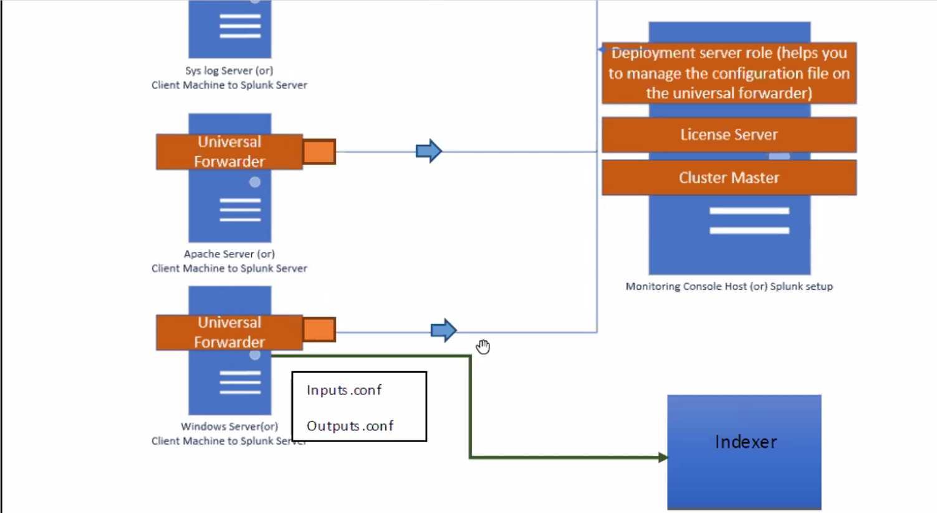

**Those add-on mainly have conf files and will give info like where data shd go**

**Addon helps to collect data from dif sources as well as monitor config files**

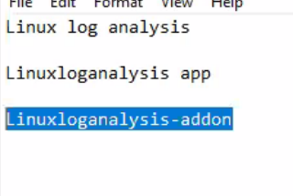

**Here add on shd be created under deployment-apps wich helps to push data to client from deployment server**

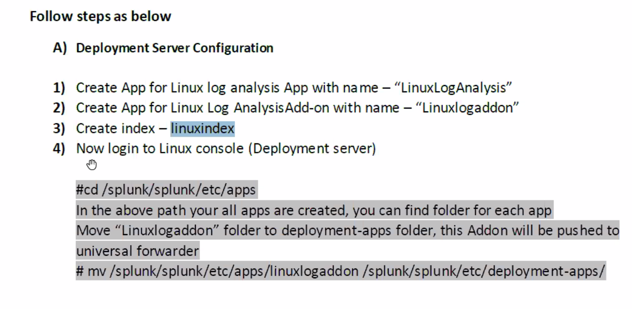

**As soon as u move add on to deployment-apps, u can see it under forwarder management**

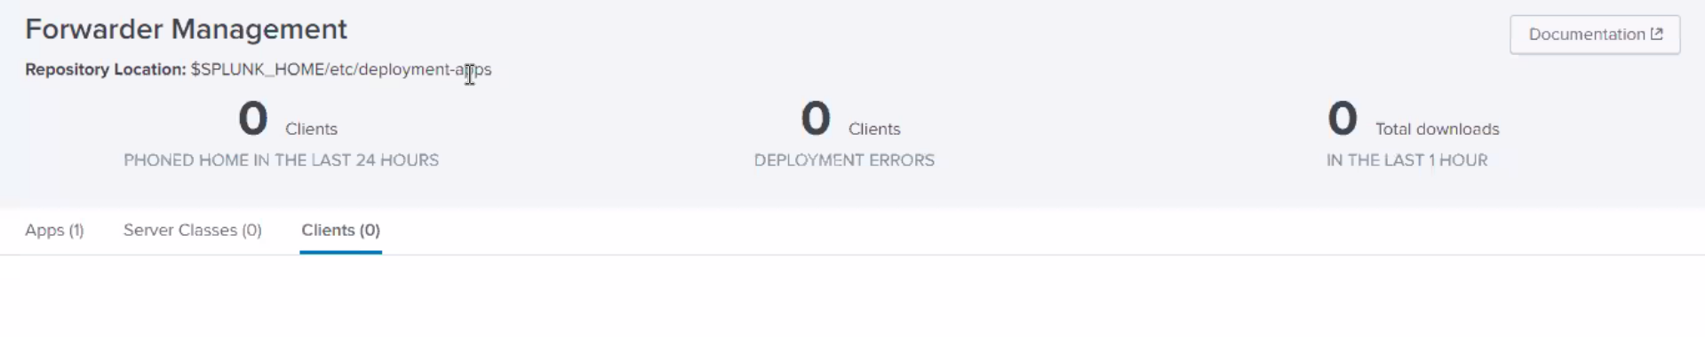

**As a part of this deployment server config we have considered single instance**

**Where first we created app for front end and add on for back end to push config files to client**

**And then we created index on same deployment server and also configured receiving port(receiver config)**

**Then we also configured cutom TCP(9997,8089) under AWS console**

**So ehre we have considered both indexer as well as deplynemt server as same instance**

**As part of deployment server config, we have created app and add on  
moved add on to deployment-apps  
as we considered indexer also same instance  
crate index and configure receiving prot as well**

**And to avoid firewall issue, we have custom tcp(8089,9997) as well**

**Now we shd configure client**

* **Launch new instance in EC2**
* **Install UF and enable boot start in newly**
* **Then create deploymentlcient.conf and specify ur deployment server**
* **Restart it**
* **Once done, we are done wth client configuration and app(add-on)**
* **Now we shd make this apps communicate to client**
* **For that we shd create server class**
* 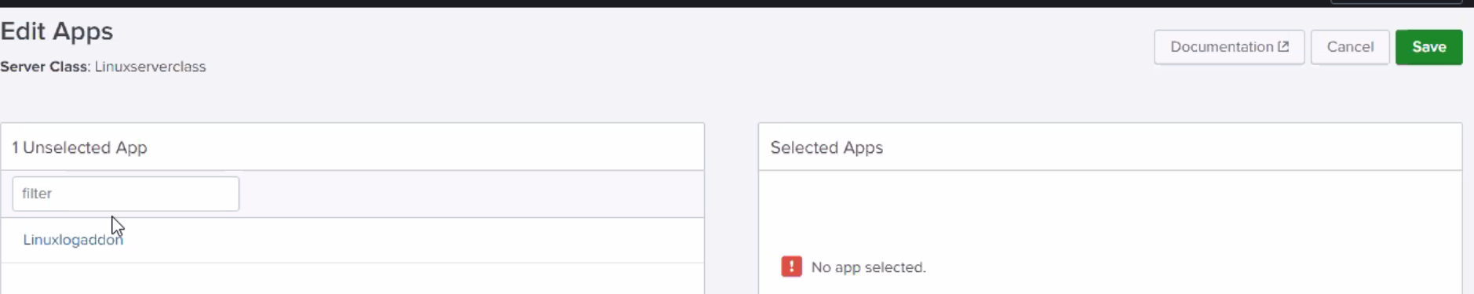
* **After createion, u can see this add on in UF under /etc/apps**
* **To make changes visible in client as soon as u made in deployment server, u shd enable splubkd**
* 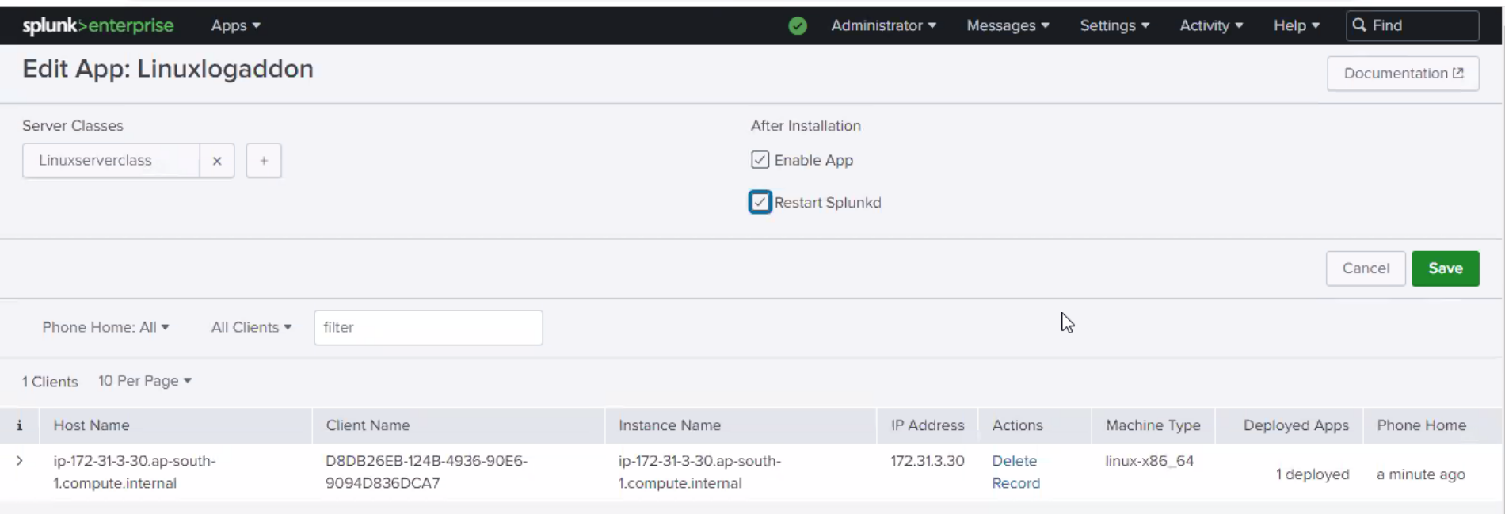
* 
* **Now, if u see u can chec those logs**

**Now we shd push configuration from add on to forwarder  
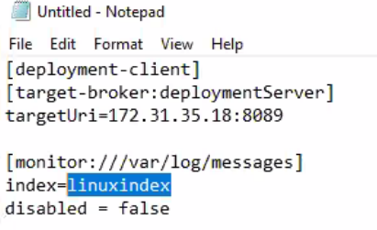**

**Put this under deplymnet-apps/our add-on  
**

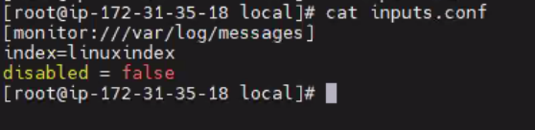

**Once done, then outputs.conf**

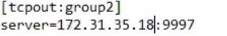

**Now to make it sp;uk, under deployment server, u can run command as   
./splunk reload deploy-server**

**Else u can go to apps under forwarder management in deployment server, just click save as we already enabled splunkd**

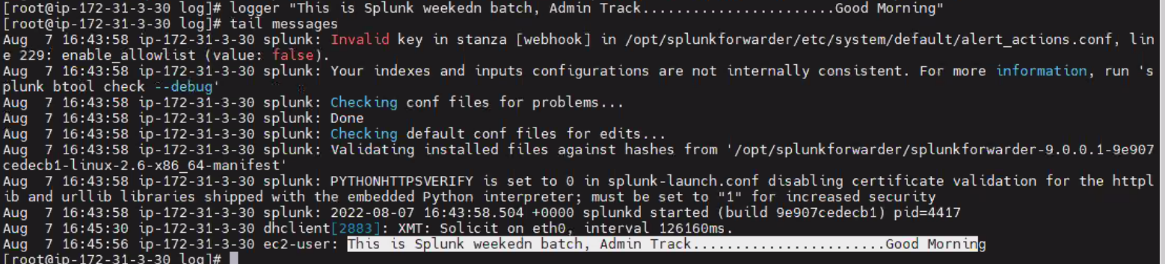

**To make it sync automatically, u shd run ./splunk reload deploy-server**

**And if we have dif config then we shd go with dif add-on**

**Create client as webserver:**

* **Run** spluk website script
* **And add 80 as custome tcp rule**
* **Check in web it will able to access now**
* **Now we shd enable weblogs in deployment client so edit inputs.conf under deployment client**
* 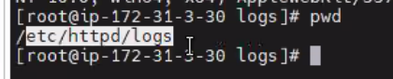
* 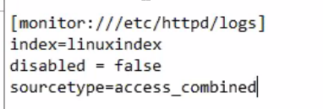
* **We didn’t mention for syslog since by deault it takes but here its good to mention**
* **Thse thing we shd define in deployment cient under inputs.conf and then run reload server command to make it sync**
* **Once done go and check in indexer and run index u can see data**
* **To keep any scripts u shd keep under bin folder**
* 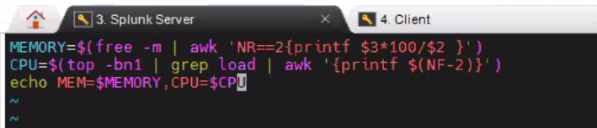
* **This shd kept under deployment server**
* 
* **And run ./data/sh it shd give cpu and mem value**
* **Now, to define thsis or to make this data to be pushed to forwarder from deployment server,’** 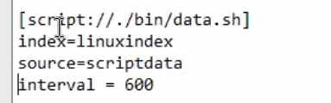
* This shd keep under inputs.conf
* And then check in client u can see changes under /linuxaddon/local/inputs.conf
* 

**If suppose we get permission issue, check wehter splunk is previlaged user run below command to check**

**If we need to collect data from third party source/vendor, mostly we will not get permission issue.**

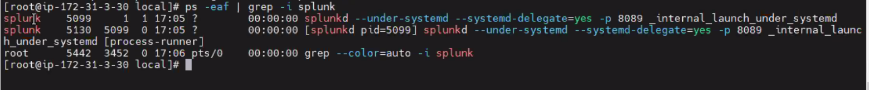

**-**

**U can refer splunk UFT script under module 8 to install and enable it**

**Here its not required to create separate folder like /splunk we did for normal instance .**

**All instance under same n/w communicate to each other using private n/w**

**So, to connect client to deployment server, we shd use private ip and not public as we use it for temporarily provision to internet.**

**After setting client, if u go and check in its log tail -f splunkd.log u can see handshake keyword whch means its done**

**Heavy forwarder:**

* If there are 100 forwarders connecting to same indexer using tcp, then load will increase and indexer may get busy in handling UF and hence it impacts serach head request.
* If we have more than 500 forwarder, then it shd required to have 2 heavy forwarder.
* So instead of indexer u shd mention heavy forwarder ip.
* To install, install full fledged splunk instance
* Here it sdha cept data from UF and also it shd forward data to indexer.
* So go to forwarder managerment ->configure receiving  
  configure forwarding
* 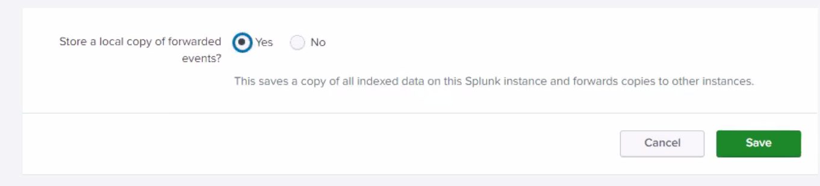
* Tis is not recommended
* U can also use heavy forwarder for filteration as well
* Here if u dnt want to push events then u can use format as nullqueue
* 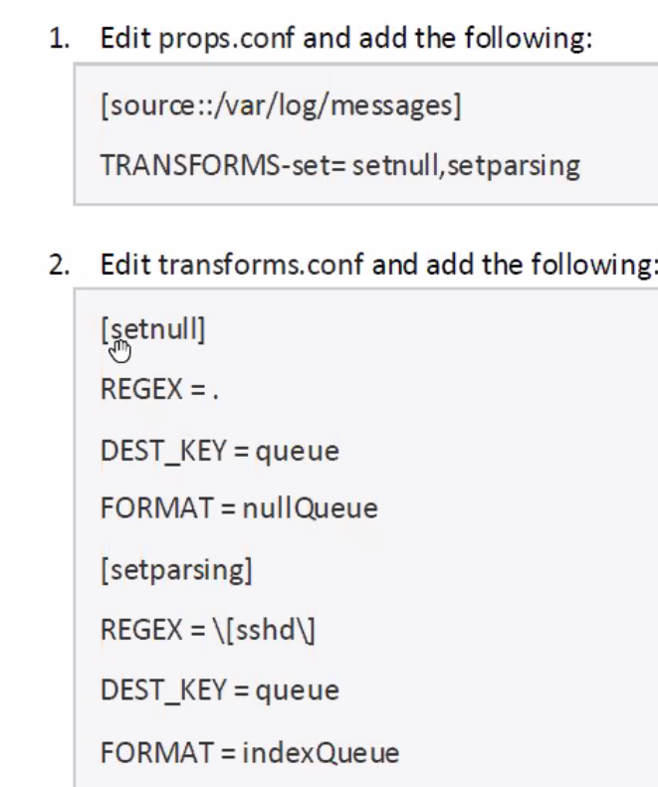
* Here if u see, except sshd other I dnt want to push in that case I used TRANSFORMS-set where I defined indexQueue and nullQueue
* And to specify events to set of target grup then use
* TrANSFORMS-routng  
  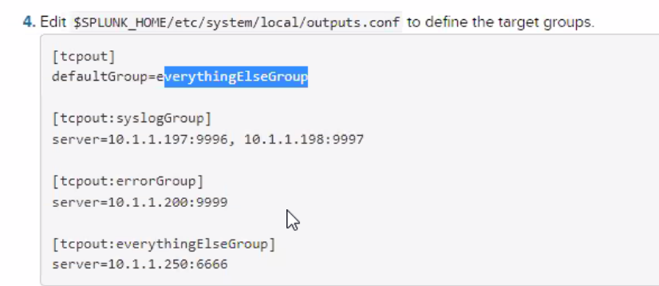
* 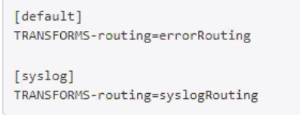
* 
* 
* If you are indexing data from heavy forwarder then u shd add that as slave

